**2D & 3D screenshots**

**A.1 2D Circuit Breaker Model Geometry**

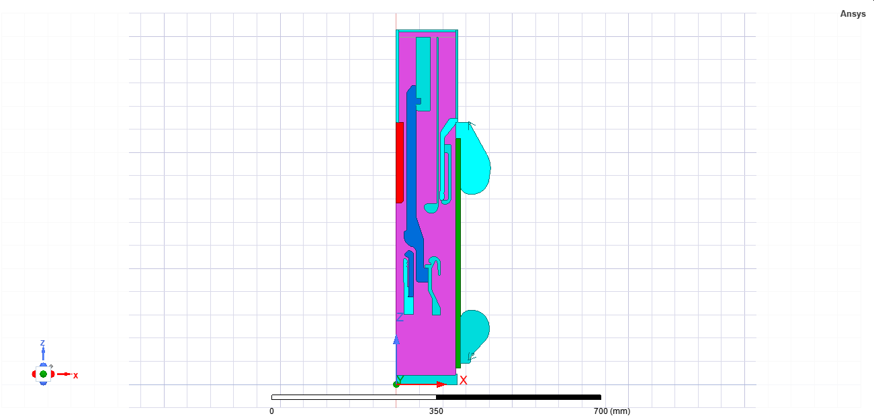

Fig A.1.1 - Cross-sectional layout of contact electrodes and spacers

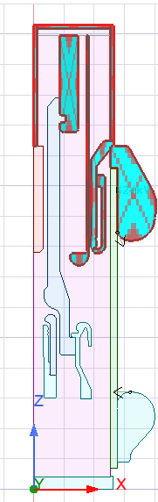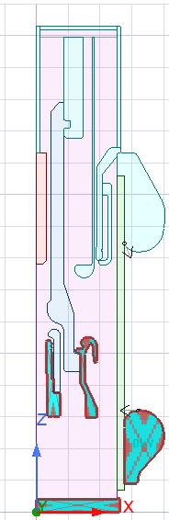

Fig A.1.2 - Boundary setup with voltage excitation and ground assignment

**A.2 3D Parallel-Plate Capacitor Model Geometry**

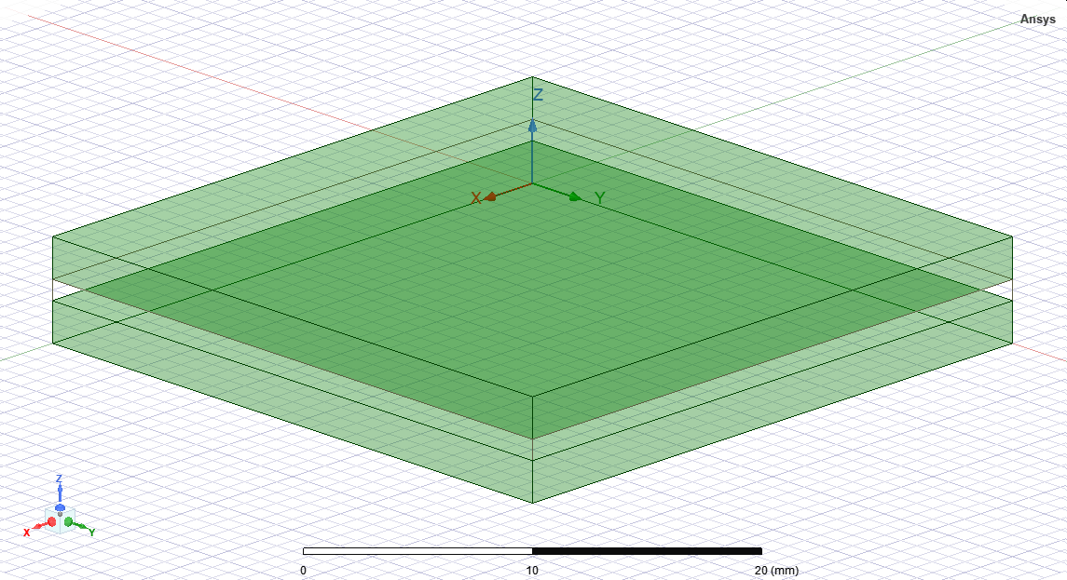

Fig A.2.1 - Full geometry view showing plate dimensions and separation

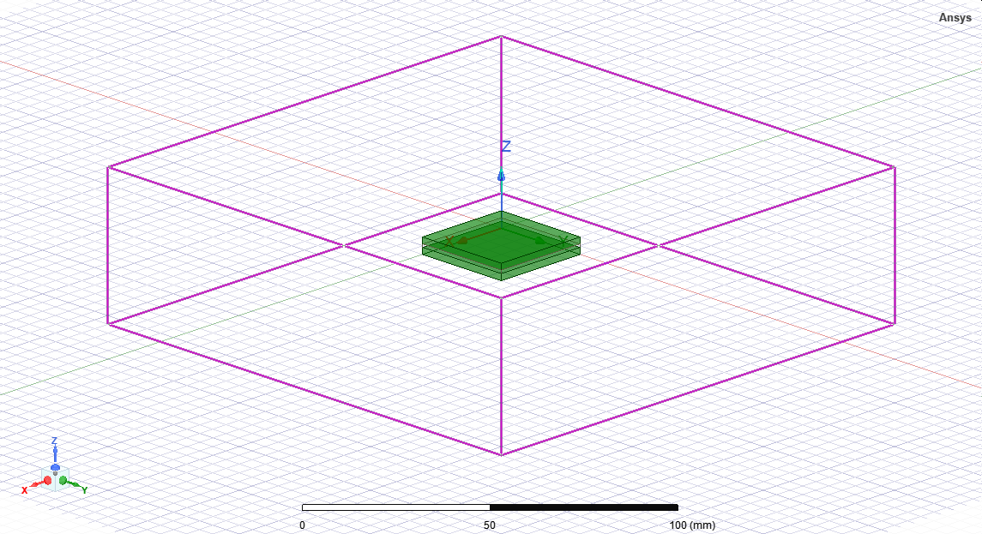

Fig A.2.2 - Field analysis region highlighting edge effect boundaries

**Appendix B: Mesh Configuration Screenshots**

**B.1 2D Model Mesh Details**

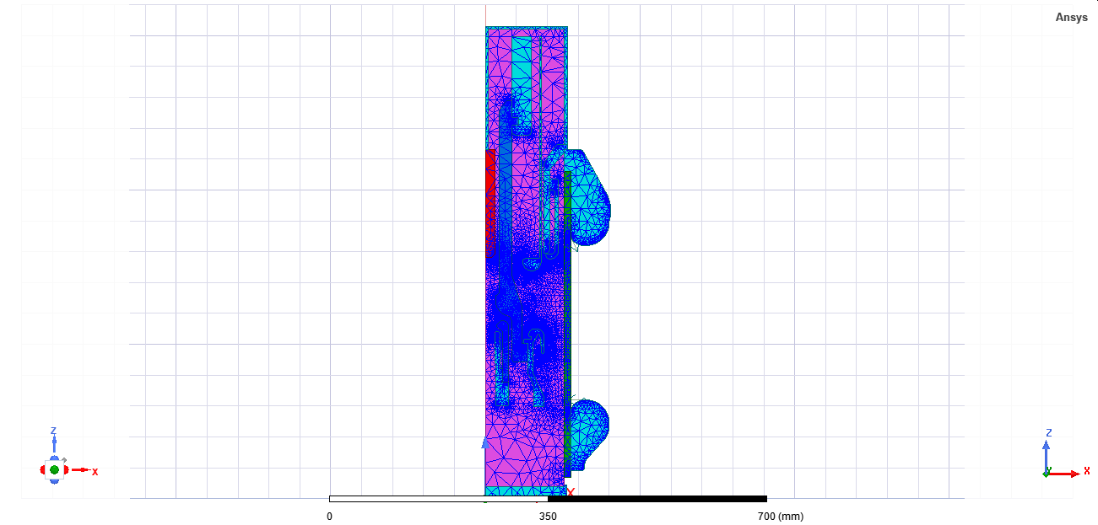

Fig B.1.1 - Triangular mesh view for circuit breaker

**B.2 3D Model Mesh Details**

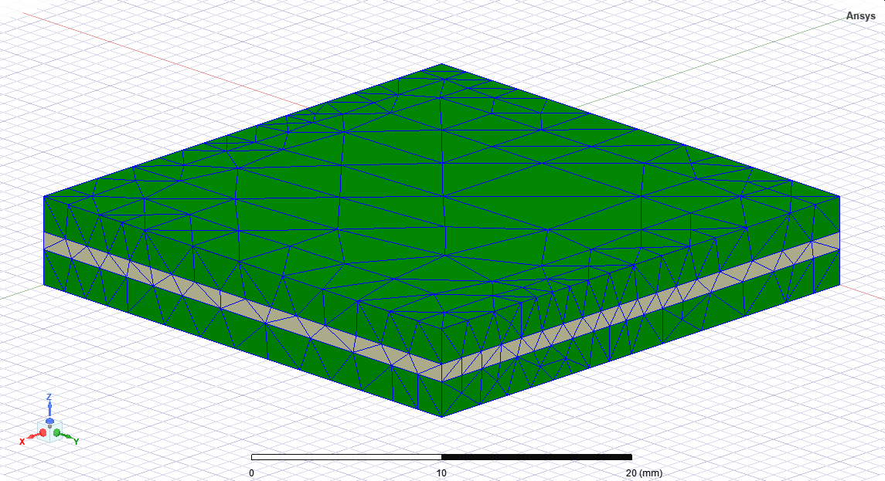

Fig B.2.1 - Tetrahedral mesh view for capacitor plates and dielectric

**Appendix C: Field Contour Outputs**

**C.1 2D Circuit Breaker Field Results**

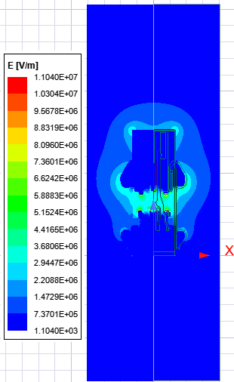

Fig C.1.1 - Electric field contour (E-field in V/m)

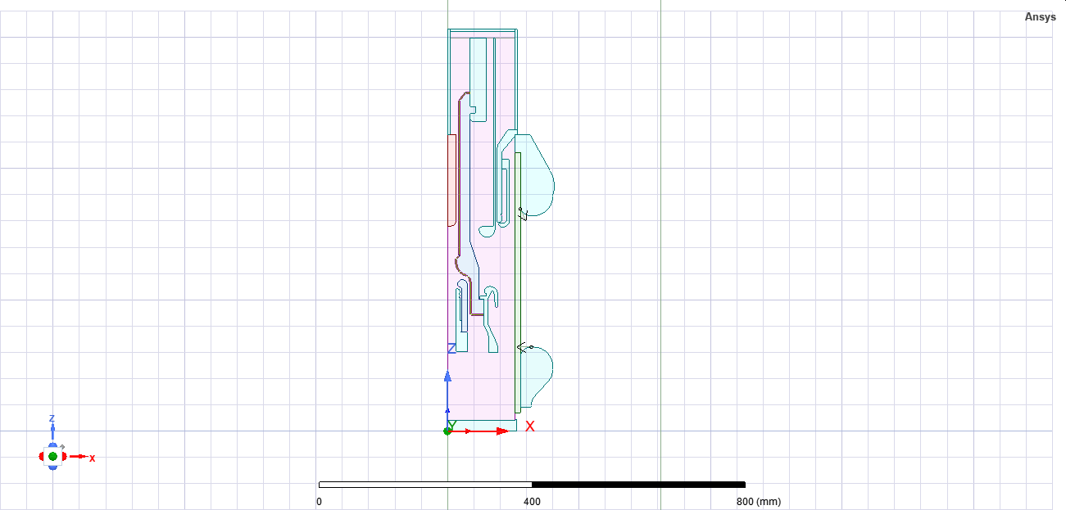

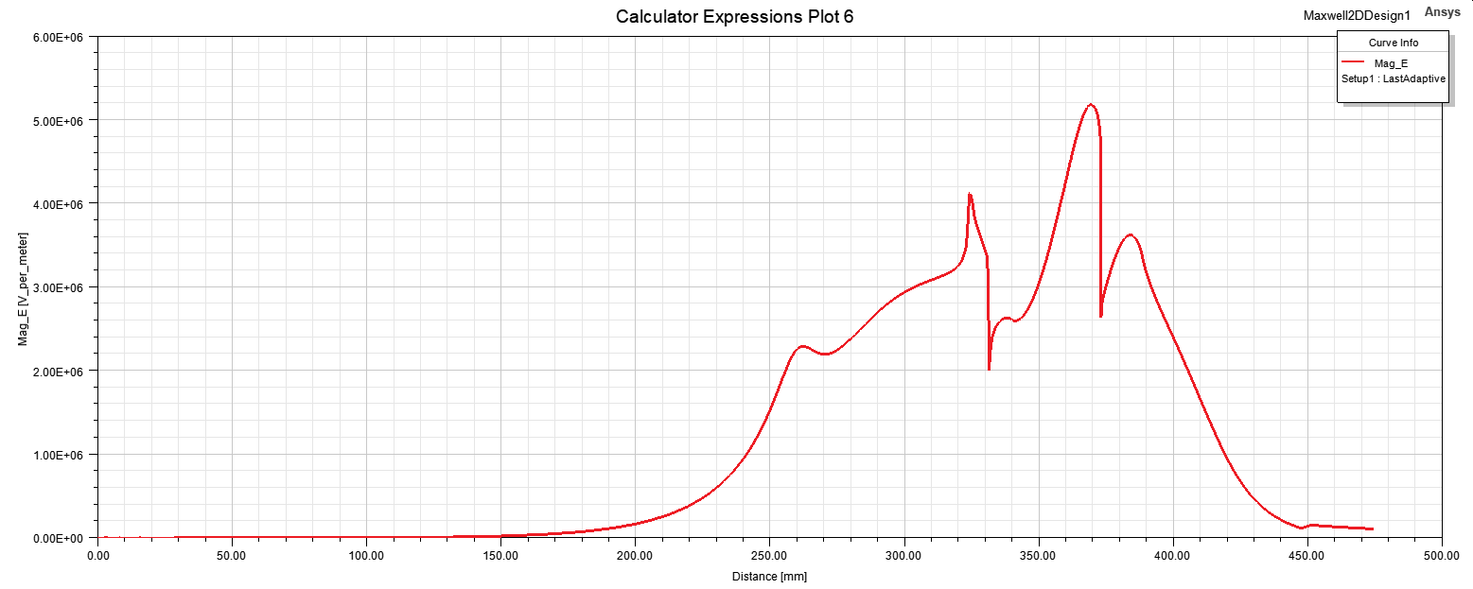

Fig C.1.2 – Geometry representation and Electric field graph of nozzle

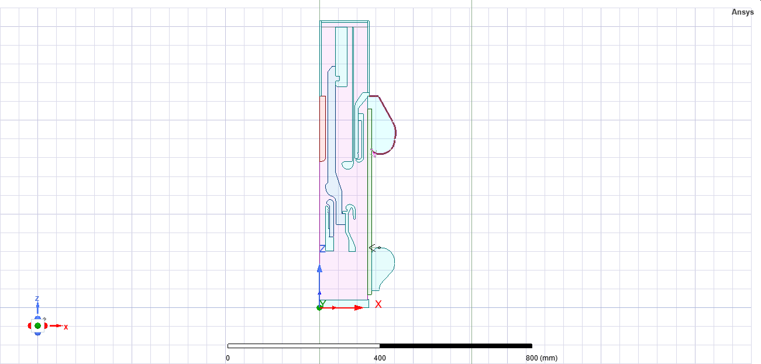

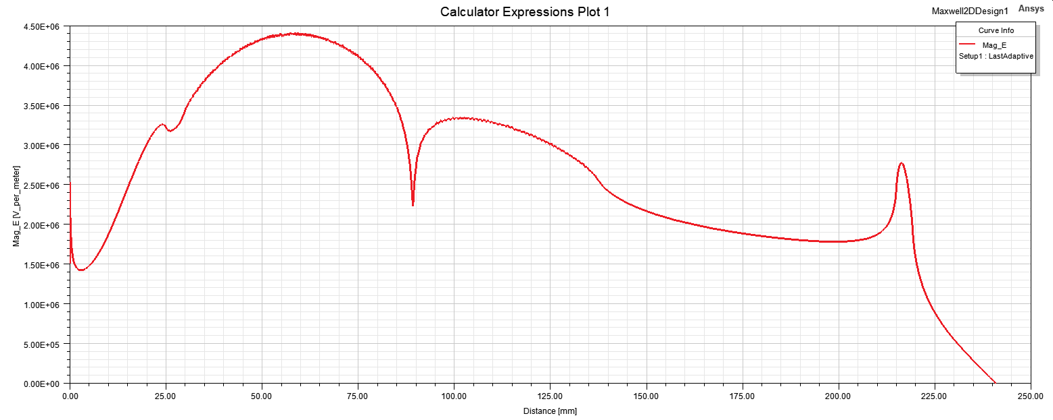

Fig C.1.3 - Geometry representation and Electric field graph of upper shield

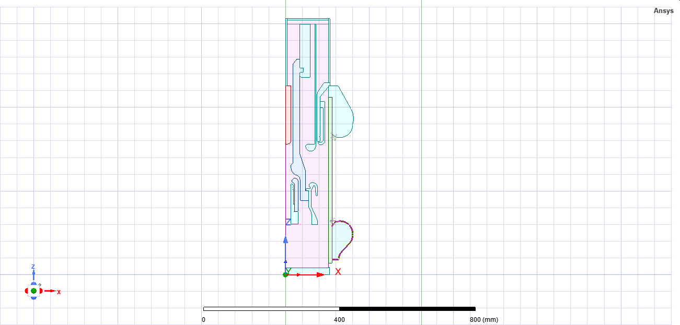

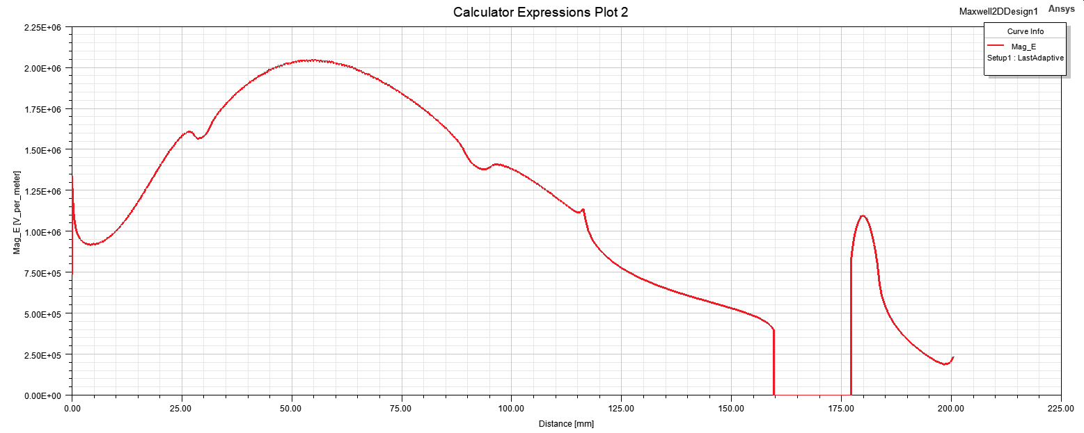

Fig C.1.4 – Geometry representation and Electric field graph of lower shield

**C.2 3D Capacitor Field Visualization**

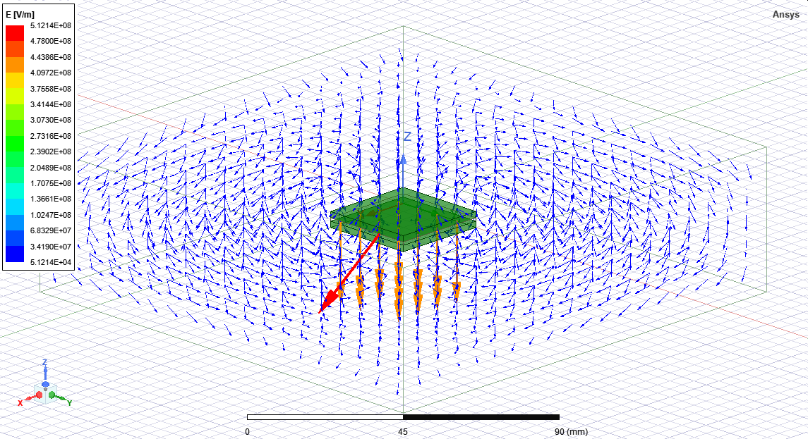

Fig C.2.1 - E-field vector distribution

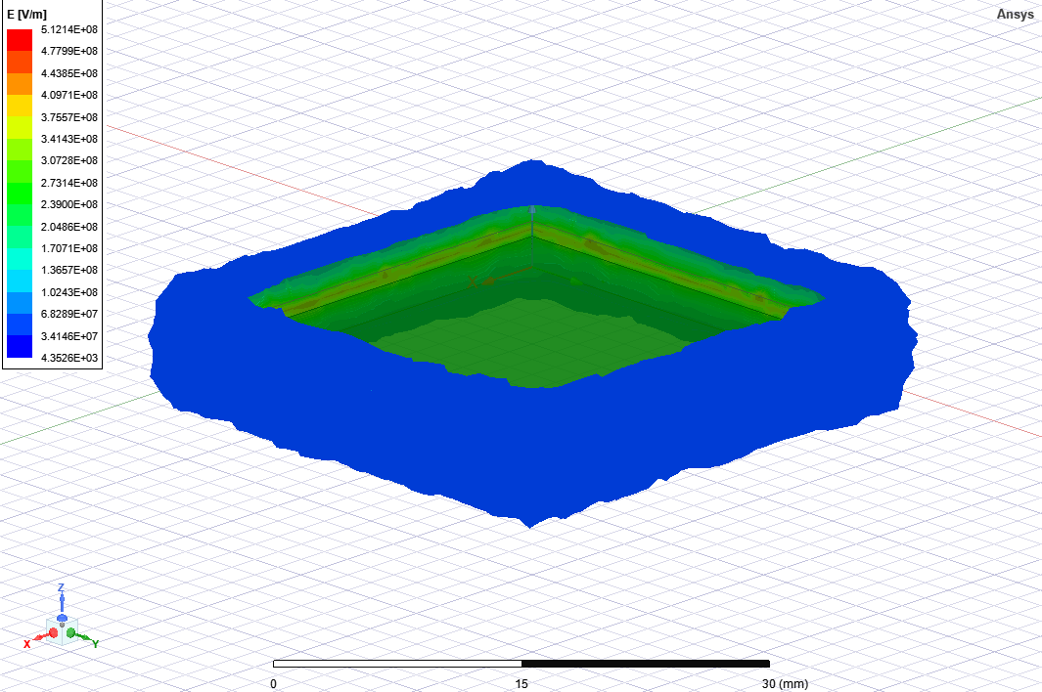

Fig C.2.2 - Electric field intensity contour (E-field in V/m)